**Welcome to The National Association of Therapeutic Parents**

Your agency has signed up to The National Association of Therapeutic Parents! We are pleased to announce you are invited to join this organisation for free, please see all information below and the code you need to quote to activate this membership.

**Who are NATP?**

The NATP was founded in 2017 by Sarah Naish to provide support, training and advice to all families of children who have suffered developmental trauma. It is now run by her daughter Rosie Jefferies along with a board of directors and core staff who all have experience in child trauma, through either supporting traumatised children themselves or being a former child in care, and therefore have a depth of understanding which is really appreciated by the families we support.

*Please see here short video explaining more about NATP* [*www.youtube.com/watch?v=RSc-2WmkUgg*](http://www.youtube.com/watch?v=RSc-2WmkUgg)

**What is Therapeutic Parenting?**

**Therapeutic Parenting** is a nurturing parenting style developed from consistent, empathic, insightful connected responses to a child’s distress and behaviours, allowing the child to begin to self-regulate and develop an understanding of their behaviours and ultimately form secure attachments and minimise the impact of childhood trauma.

**Therapeutic Parenting** helps to create new pathways in the child’s brain to link cause and effect, reduce levels of fear and shame, and help the child make sense of their world.

**Therapeutic Parenting** uses empathy and connection to guide behaviours and help children understand where they came from**. Therapeutic Parenting** recognises that behaviour is communication, which is often based in fear. It also emphasises a need for parents to respond to the child’s emotional age, not their chronological age.

**What can the NATP do for me?**

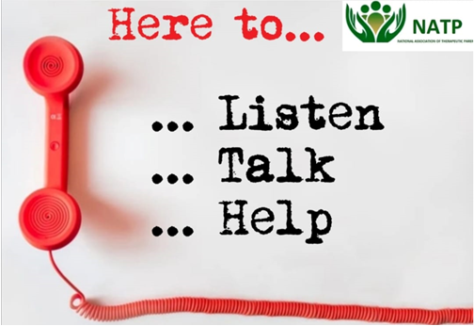If you are looking after children who have suffered early life trauma through pre-natal stress, neglect or other abuse, NATP can support you.  Membership of NATP offers a range of benefits:

**Support Network: Listening Circles** – All members are allocated to a listening circle – this is a support group where parents can talk through their issues, find support and strategies, but most importantly meet up with families in the same kinds of situations with the same sorts of experiences.  Time out for you, in a secure confidential environment.  **We also hold these virtually for those that cannot attend for a variety of reasons.**

**Support Network: Peer support online –** All members are invited to join closed Facebook group for members.  This is a closed moderated group where members are able to air their own issues, ask for advice and strategies, vent or even share their triumphs and good news!

**Members Hotline** – Members can call the empathic hotline in order to be directed to the correct support. This may be a 1-2-1 consultation, resource, training, free videos or one of the many other services we provide.

**Website -** As a members you can access the NATP Website ([www.naotp.com](http://www.naotp.com)) for:

* **Resources** – handouts, videos, essential downloadable letters to schools, articles, links and much more.
* **Events –** Keep up to date with our events, training, listening circles and family tailored events.
* **Recommendations –** Our members will share their personal recommendations for therapists and schools they can feel are trauma informed and have helped their child and family.
* **Books –** The book section is to support and aid parents with Therapeutic Parenting and related subjects. These have been recommended by NATP Members for parents, and for children to read with parents.
* **Shop –** NATP have shop with a variety of items in, all aimed to help families with different behaviours. For example, timetables for regulation.

**In addition, as result of the current Covid-19 situation, we have added these additional services:**

* Parents Space – This is a virtual support group that is run every evening for members to take part in to gain support, advice and to vent about any difficulties you are facing at present, coronavirus related or not.
* Weekly webinars running on a variety of subjects to help support our members through this tough time.  Topics include home schooling, maintaining PACE in a crisis, compassion fatigue and many more.
* Opportunity for 1-2-1 support calls for members. **We are pleased to announce this will be continuing for all members for the foreseeable future.**

**Training -** From our specialist training provider Inspire Training Group.

* Face to face events
* Webinars
* Online training

*After joining all information will be provided about these services and how to access them in your welcome email, including how to take advantage of the 50% members discount.*

**And so much more…**

**How do I Join?**

**As a Parent of Adoption East Midlands your membership has already been paid for!** To access the above support, simply email [membership@naotp.com](mailto:membership@naotp.com) and request code from AEM Adoption Support duty, phone number: 0115 8044500

**\*Please note if you are applying for membership as a supporting professional, please make us aware when signing up that you require an Associates Membership.**

The rest will be done for you!

**We hope you will join us and look forward to welcoming you to our community!**

**NATP Team.**

**NATP Ltd t/a The National Association of Therapeutic Parents.**

**Company registration number 10705603**

[www.naotp.com](http://www.naotp.com/)

Recognised organisation of Centre of Excellence in child trauma

[www.coect.co.uk](http://www.coect.co.uk/)